UNIT-II
- Operating System

An operating system is a type of software that acts as an interface between the user and the hardware. It is responsible for handling various critical functions of the computer and utilizing resources very efficiently so the operating system is also known as a resource manager.

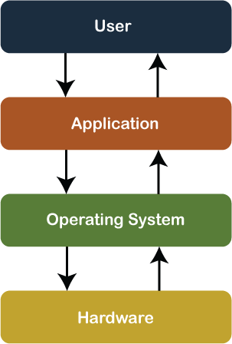
Furthermore, an operating is a software program that manages and controls the execution of application programs, software resources and computer hardware. It also helps manage the software/hardware resource, such as file management, memory management, input/ output and many peripheral devices like a disk drive, printers, etc. These are the popular operating system: Linux OS, Windows OS, Mac OS, VMS, OS/400 etc.

The operating system has two objectives:
  - Managing the Computer’s hardware: The prime objective of the operating system is to manage and control various hardware resources of a computer system.
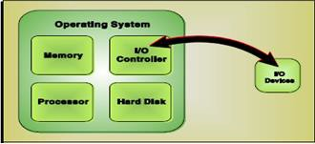

  - Providing an Interface: The operating system organizes applications so that users can easily access, use, and store them. When an application is opened, the operating system assists the application to provide the major part of the user interface. It provides a stable and consistent way for applications to deal with the hardware.

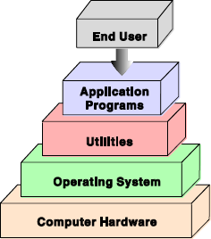

Evolution of Operating System
- In the early days, the computers lacked any form of operating system. Then came machines with libraries of support code (initial operating systems), which were linked to the user’s program to assist in operations such as input and output.
- At this stage, operating systems were very diverse with each vendor producing one or more operating systems specific to its particular hardware.
- The development of microprocessors provided inexpensive computing for the small businesses. The most important among the early operating systems was CP/M-80 for the 8080/8085/Z-80 microprocessors.
- AT&T and Microsoft came up with character-based operating systems, namely, Unix and Disk Operating System (DOS), respectively which supported the prevalent hardware architectures.
- After the character-based operating systems, Microsoft and Apple Macintosh came with their Windows 3.1 and MAC, which were GUI-based operating systems and well suited for the Desktop PC market.

Common Functions/ Services offered by an almost all operating systems:
  - Processor management
  - Act as a Resource Manager
  - Memory Management
  - File Management
  - Security
  - Device Management
  - Input devices / Output devices
  - Deadlock Prevention
  - Time Management
  - Coordinate with system software or hardware
  - User Interface

Types of OS

- Batch Operating System
- Multiprogramming Operating System
- Multitasking Operating System
- Time-Sharing Operating System
- Embedded Operating System
- Network Operating System
- Distributed Operating System
- Multiprocessing Operating System
- Real-Time Operating System

- Batch OS – A set of similar jobs are stored in the main memory for execution. A job gets assigned to the CPU, only when the execution of the previous job completes. Therefore, the user needs to prepare jobs and save offline mode to punch card or paper tape or magnetic tape. After creating the jobs, hand it over to the computer operator; then the operator sort or creates the similar types of batches like B2, B3, and B4. Now, the computer operator submits batches into the CPU to execute the jobs one by one. After that, CPUs start executing jobs, and when all jobs are finished, the computer operator provides the output to the user.

- Multiprogramming OS – The main memory consists of jobs waiting for CPU time. The OS selects one of the processes and assigns it to the CPU. Whenever the executing process needs to wait for any other operation (like I/O), the OS selects another process from the job queue and assigns it to the CPU. This way, the CPU is never kept idle and the user gets the flavor of getting multiple tasks done at once.
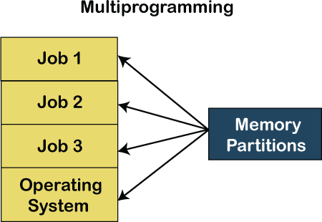

- Multitasking OS – Multitasking OS combines the benefits of Multiprogramming OS and CPU scheduling to perform quick switches between jobs. The switch is so quick that the user can interact with each program as it runs.

- Time Sharing OS – It is the type of operating system that allows us to connect many people located at different locations to share and use a specific system at a single time. The time-sharing operating system is the logical extension of the multiprogramming through which users can run multiple tasks concurrently. Furthermore, it provides each user his terminal for input or output that

impacts the program or processor currently running on the system. It represents the CPU's time is shared between many user processes. Or, the processor's time that is shared between multiple users simultaneously termed as time-sharing.

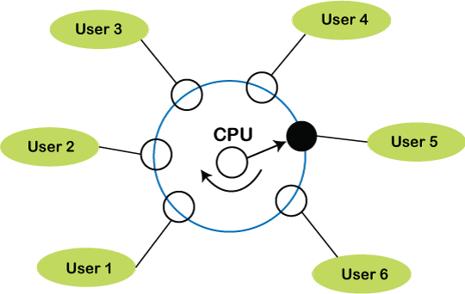

Embedded Operating System

The Embedded operating system is the specific purpose operating system used in the computer system's embedded hardware configuration. These operating systems are designed to work on dedicated devices like automated teller machines (ATMs), airplane systems, digital home assistants, and the internet of things (IoT) devices.
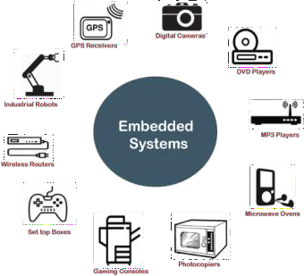

Network Operating System

A network operating system is an important category of the operating system that operates on a server using network devices like a switch, router, or firewall to handle data, applications and other network resources. It provides connectivity among the autonomous operating system, called as a network operating system. The network operating system is also useful to share data, files, hardware devices and printer resources among multiple computers to communicate with each other.

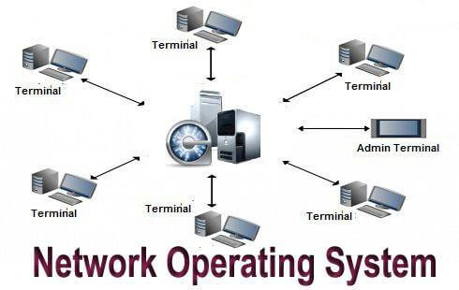

Types of network operating system
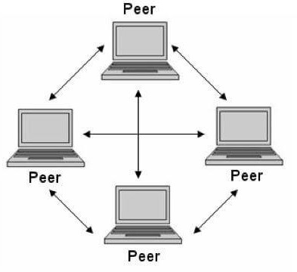
  - Peer-to-peer network operating system: The type of network operating system allows users to share files, resources between two or more computer machines using a LAN.
  - Client-Server network operating system: It is the type of network operating system that allows the users to access resources, functions, and applications through a common server or center hub of the resources. The client workstation can access all resources that exist in the central hub of the network. Multiple clients can access and share different

Distributed Operating system

A distributed operating system provides an environment in which multiple independent CPU or processor communicates with each other through physically separate computational nodes. Each node contains specific software that communicates with the global aggregate operating system. With the ease of a distributed system, the programmer or developer can easily access any operating system and resource to execute the computational tasks and achieve a common goal. It is the extension of a network operating system that facilitates a high degree of connectivity to communicate with other users over the network.
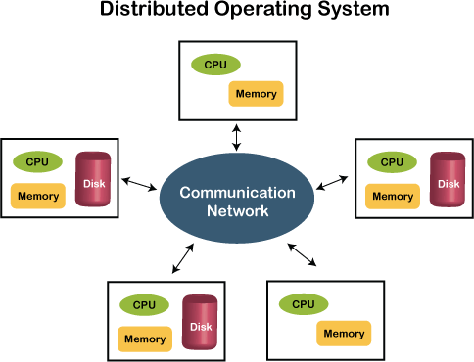

Multiprocessing Operating System

It is the type of operating system that refers to using two or more central processing units (CPU) in a single computer system. However, these multiprocessor systems or parallel operating systems are used to increase the computer system's efficiency. With the use of a multiprocessor system, they share computer bus, clock, memory and input or output device for concurrent execution of process or program and resource management in the CPU.

- Real Time OS – Real-Time OS are usually built for dedicated systems to accomplish a specific set of tasks within deadlines. For example, real-life situations governing an automatic car, traffic signal, nuclear reactor or an aircraft require an immediate response to complete tasks within a specified time delay. Hence, a real-time operating system must be fast and responsive for an embedded system, weapon system, robots, scientific research & experiments and various real-time objects.

Types of the real-time operating system:
  - Hard Real-Time System

These types of OS are used with those required to complete critical tasks within the defined time limit. If the response time is high, it is not accepted by the system or may face serious issues like a system failure. In a hard real-time system, the secondary storage is either limited or missing, so these systems stored data in the ROM.

Soft Real-Time System
A soft real-time system is a less restrictive system that can accept software and hardware resources delays by the operating system. In a soft real-time system, a critical task prioritizes less important tasks, and that priority retains active until completion of the task. Also, a time limit is set for a specific job, which enables short time delays for further tasks that are acceptable. For example, computer audio or video, virtual reality, reservation system, projects like undersea, etc.

DOS (Disk Operating System)
DOS is a platform-independent acronym for disk operating system which later became a common shorthand for disk-based operating systems on IBM PC compatibles. DOS primarily consists of Microsoft's MS-DOS and a rebranded version under the name IBM PC DOS, both of which were introduced in 1981.
DOS Commands are instructions to perform tasks on files and directories very useful to Windows users. DOS commands are case insensitive. And as you already know, file is the area where we store group of information or data, and collection of groups of files is called a directory.
In MS-DOS the file name follows 8dot3 format and is divided into two parts – primary name and secondary name. Primary name is up to 8 characters long and secondary name is up to 4 characters with dot. For example, in the file-name Logo.jpg, Logo is the primary name and .jpg is the secondary name. Secondary names are fixed for particular type of file, meaning for system files the secondary name is designated as .sys, for text files it is .txt and so on. To name a file or directory special characters like < > , . / * ? | & Space are not allowed. Here is the list of some of the important types of files with their default secondary names:

Text file | .txt
Command file | .com
System file | .sys
Programme file | .prg
Database file | .dbm
Library file | .lib
Batch file | .bat
Executable file | .exe

DOS Commands
DOS Commands are divided into 2 types:

Internal Commands
These are for performing basic operations on files and directories and they do not need any external file support.

External Commands
These external commands are for performing advanced tasks and they do need some external file support as they are not stored in COMMAND.COM

There are also Batch commands or Batch files which are text files that contain a list of internal and/or external commands which are executed in sequence when the batch file is executed. AUTOEXEC.BAT gets executed automatically on booting.
In MS-DOS, keyboard shortcuts involving handy ones like Functional keys, arrows, pipe character (” | “), asterisk (*), ?, [] and ESC are of great help for recalling to searching to clearing command line etc.

Internal DOS Commands

DATE
This command is used to display the system current date setting and prompt us to enter a new date. The syntax is: DATE [/T | date]
If we type DATE without parameters then it displays current date and prompts to enter new date. We should give new date in mm-dd-yy format. If we want to keep the same date just Press ENTER. DATE command with /T switch tells the command to just output the current system date, without prompting for a new date.

TIME
This command is used to displays or set the system time. The syntax is: TIME [/T | time]
Same as DATE command, typing TIME with no parameters displays the current time and a prompt for a new one. Press ENTER to keep the same time. TIME command used with /T switch tells the command to just output the current system time, without prompting for a new time.

COPY CON
It is used to create a file in the existing directory. Here CON is a DOS reserved word which stands for console. Syntax is: COPY CON filename after that press Enter and start typing your text and after we’re done typing our text, to save and exit hit F6 key.

TYPE

This command is used to display the contents of a text file or files. The syntax is: TYPE [drive:][path]filename Now, lets try to display the contents of the file named filename we’ve created earlier using COPY CON command.

CLS
It is used to clear the screen. Syntax is CLS

REN
This command is used to change/modify the name of a file or files. Syntax is: REN [drive:] [path] filename1 filename2.
Here, filename1 is source file for which we wanted to change the name, and filename2 will obviously become our new file name. Also note that we cannot specify a new drive or path for our destination file.

DIR
This command displays a list of files and subdirectories in a directory.

Syntax is: DIR [drive:] [path] [filename] [/A[[:]attributes]] [/B] [/C] [/D] [/L] [/N]
[/O[[:]sortorder]] [/P] [/Q] [/S] [/T[[:]timefield]] [/W] [/X] [/4]
Here,
[drive:][path][filename] | Specifies drive, directory, and/or files to list.
/A:attributes | Displays files with specified attributes. The possible attributes are as follow: D → Directories, R → Read-only files, H → Hidden files, A → Files ready for archiving, S → System files, – Prefix meaning not
/B | display in bare format with no heading information or summary
/C | Using this attribute with dir by default displays the thousand separator in file sizes. To disable display or separator use /-C
/D | Displays file list sorted by column.
/L | Uses lowercase in listing file names and sub-directories.
/N | Display in new long list format where filenames are on the far right.

/O:sortorder | Displays list by files in sorted order. The sortorder attributes are as follow: N → By name (alphabetic), S → By size (smallest first), E → By extension (alphabetic), D → By date/time (oldest first), G → Group directories first, – Prefix to reverse order

/P | Display page wise pausing after each screenful of information and prompts to press any key to continue.
/Q | Displays the owner of a file or files.
/S | Displays files in specified directory and all subdirectories. Bear caution in using this in your root directory as you may end up in overflowing information. To stop the screen overflow at any point hit Pause-Break key.
T:timefield | This sorts and displays the list based on time field specified. C for Creation, A for Last Access, W for Last Written
/W | Displays list width wise or wide list format.
/X | This is used to display the short names generated for non-8dot3 file names.

Note that switches may be different in the DIRCMD environment variable, in which case just override present switches by prefixing any switch with – (hyphen), for example instead of using
/P use /-P

PATH
This command displays the path that how we have come to the present position or sets a search path for executable files.
Syntax is PATH [[drive:]path[;…][;%PATH%]]
Typing PATH without any parameters displays the current path under current directory. Typing PATH ; clears all search-path settings and direct cmd.exe to search only in the current directory. And including %PATH% in the new path setting causes the old path to be appended to the new setting.

VER
This command displays the version of the Microsoft Windows running on our computer.

VOL

It displays the disk volume label and serial number, if they exist for the drive specified. If no drive is specified it displays for the active drive. Syntax is VOL [drive:]

DEL/ERASE
Used to delete one or more files.
Syntax is DEL [/P] [/F] [/S] [/Q] [/A[[:]attributes]] names Here, tr>

names | Specifies a list of one or more files or directories. Wildcards * and ? may be used to delete multiple files. * indicates group of unknown characters whereas using wildcard ? in file-names is for single unknown character. And using this command if a directory is specified, all files within the directory will be deleted.
/P | Prompts for (Y)es/(N)o confirmation before deleting each file.
/F | Used to force delete read-only files.
/S | Delete specified files from all subdirectories. If Command Extensions are enabled DEL and ERASE change while using /S switch such that it shows you only the files that are deleted, not the ones it could not find.
/Q | Delete in quite mode and do not ask if ok to delete on global wildcard
/A:attributes | Delete files based on specified attribute. The attributes are: R for Read-only files, S for System files, H for Hidden files, A for files ready for archiving and – Prefix meaning not.

COPY
This command is useful in copying one or more files to another file or location.

Syntax is COPY [/D] [/V] [/N] [/Y | /-Y] [/Z] [/A | /B ] source [/A | /B] [+ source [/A | /B] [+
…]] [destination [/A | /B]].
The different switches that can be used with this command as follow along with their use.
source | It specifies the file or files to be copied.
/A | Indicates an ASCII text file.
/B | This switch indicates a binary file.
/D | This allows the destination file to be created with decryption.
destination | This specifies the directory and/or filename for the new file or files.
/V | Helps to verify new files to be written correctly.
/N | Specifying this switch uses short filename, if available, when copying a file with a non-8dot3 file name.
/Y | If destination file already exists, this switch suppresses prompting to confirm you want to overwrite it and does it asap.
/-Y | Contrary to above switch, this causes prompting to confirm you want to overwrite an existing destination file.
/Z | Copies networked files in restartable mode.

For appending multiple files for source use wildcard or file1+file2+file3 format and make sure to specify a single file for destination.

MD (or MKDIR)
This command stands for make directory and it is used to create a directory. Syntax is MD [drive:]path

CD (or CHDIR)
This stands for create or change directory and it allows to display the name of or change the current directory or rather we can say come out of a directory.
Syntax is CD [/D] [drive:][path] → Typing CD drive: displays the current directory in the specified drive. This CD (or CHDIR) command does not treat spaces as delimiters due to which it allows to CD into a subdirectory name that contains a space without surrounding the name with quotes. For example: CHDIR program filesmozilla firefox is the same as: CHDIR “program filesmozilla firefox”

RD (or RMDIR)
This command removes or deletes a directory. There are two conditions to remove any directory
- Directory to be removed should be empty. And
- We should be outside the directory we are commanding to delete.

Syntax is RD [/S] [/Q] [drive:]path
Here, using the switch /S removes a directory tree meaning it removes all directories and files in the specified directory in addition to the directory itself. And using /Q is the quiet mode that doesn’t asks for ok approval to remove a directory tree.

MD, CD and RD
If we type CD without any parameters it displays current drive and directory. CD.. specifies that you want to change to the higher directory in the current path. Whereas, using CD you can directly change to parent/root directory from any location in the current drive.
→Using /D switch changes current drive in addition to current directory for a drive.

PROMPT
This changes the cmd.exe command prompt. By default the prompt is always set to the name of current drive followed by > sign.
Customize the Prompt
To customize the prompt to display any text of your choice, use the syntax prompt anytext and this will change the prompt to new command prompt anytext.
Prompt with Options (or Special Codes)
We can use prompt with options. To let the prompt display the current working directory use prompt $p$g $p in the above signifies the current drive and path. $g signifies the greater than sign
>
The other options used with prompt command are as follows. Any combination of these can be used with prompt command. $A & (Ampersand)
$B | (pipe character)
$C ( (Left parenthesis)
$D Current date
$E Escape code (ASCII code 27)
$F ) (Right parenthesis)
$H Backspace (erases previous character)

$L < (less-than sign) $N Current drive $Q = (equal sign) $T Current time $V Windows XP version number $_ Carriage return and linefeed $$ $ (dollar sign)

External DOS Commands

EDIT
This command is used to modify or change the data of a file. Syntax is EDIT [/B] [/H] [/R] [/S] [filename(s)]

Using switch /B we can force the edit in monochrome mode. /H displays the maximum number of lines possible for our system hardware. Whereas using /R and /S one can load files in read-only mode and force the use of short filenames respectively. [filename(s)] is used to specify file(s) to go edit. You can use wildcards (* and ?) to specify multiple files.

XCOPY
This command is used to copy files and directory trees from one disk to another disk.
Syntax is XCOPY source [destination] [/A | /M] [/D[:date]] [/P] [/S [/E]] [/V] [/W] [/C] [/I] [/Q] [/F] [/L] [/G] [/H] [/R] [/T] [/U] [/K] [/N] [/O] [/X] [/Y] [/-Y] [/Z]
[/EXCLUDE:file1[+file2][+file3]…]

LABEL
It is used to create, change, or delete the volume label of a disk. Syntax is LABEL [drive:] [label] LABEL [/MP] [volume] [label]
Here, [drive:] is for specifying the drive letter of a drive to be labelled and [label] specifies the label of the volume disk. [/MP] is used to specify that the volume should be created as a mount point and [volume] is used to specify volume name, usually mentioned after drive letter followed by colon and then giving volume name required.

DISKCOPY
This command copies the contents of one floppy from the source drive to a formatted or un- formatted floppy disk in the destination drive. This command copies the data from particular position on the source disk to exactly the same position on the destination disk.
Syntax Diskcopy A: B: copies contents of A: to B: drive. This command can be used with /V switch which verifies that the disk is copied correctly.

CHKDSK
This command is used to check a disk and display a status report with properties of disk like serial number, volume label, memory and other properties along with errors on the disk if any.

Syntax is CHKDSK [volume path] [/F] [/V] [/R] [/X] [/I] [/C] [/L[:size]]
[volume path] is where we specify the drive letter followed by a colon and volume name to be checked. using /F switch allows you to fix errors on the disk. /V display full path and/or clean-up message if any. /R is used in tandem with /F and used to locate bad sectors and recover readable information. If you wanted to perform a less vigorous check of index entries on the disk then the right option is to use /I or /C rather than /R as they skip checking of cycles on the volume and helps in reducing the amount of time required to run chkdsk. Using /X forces the volume to dismount first before checking is performed. /L:size is all about specifying the log file size in kilobytes.

TREE
This command is very useful to view the list of directories and subdirectories present on the disk in graphical form. If we wanted to include files also with directories and subdirectories, then we’ll have to give the command line as tree/f which presents the tree view of all the content on our disk. Here is the syntax for this command with allowed switches: TREE [drive:path] [/F] [/A] In case we wanted use ASCII instead of extended characters, then go ahead include /A in the command line.

DELTREE
This command is used to remove a directory along with its contents. Syntax is deltree [drive:path] here, [drive:path]
specifies the directory name to be deleted. All the subdirectories and files in this directory will be deleted without prompt and there’s not getting back. So, keep caution while using this command.

DOSKEY
This command is generally used to edits command lines and recalls commands. Syntax is DOSKEY [/REINSTALL] [/HISTORY] [text]
Here, /REINSTALL installs new copy of doskey, /HISTORY is used to display all previously given commands stored in memory. And [text] specifies the commands we want to record.

FIND
This command searches for a specific text string in a file or files.

Syntax is FIND [/V] [/C] [/N] [/I] [/OFF] “string” [[drive:][path]filename[ …]]
  - Displaying all lines not containing the specified string @ /V
  - Displaying only the number count of lines containing the text string @ /C
  - Displaying line numbers with the displayed lines @ /N

The basic essential elements in the command line for find are – the string enclosed in ” ” and [[drive:][path]filename(s)]. String specifies the text string to find in the file and [[drive:][path]filename(s)] specifies the file or files where the text string search is to be done. If a path is not specified, FIND searches the text typed at the prompt or piped from another command. When we append /OFF in the command line, it searches and finds even those files with offline attribute set. Apart from searching the text string, this command is useful in:

SORT
This command is used to arrange the data of a file in alphabetical order (A-Z, 0-9) or reverse alphabetical order.

Syntax is SORT [/R] [[drive1:][path1]filename1] [/T [drive2:][path2]] [/O [drive3:][path3]filename3]
/R in command line reverses the sort order; that is, the data of the specified file sorts sorts Z to A, then 9 to 0. [drive1:][path1]filename1 specifies the file to be sorted. /T [drive2:][path2] is used in cases of data overflow in main memory and it specifies the path of the directory to hold the sort’s working storage. And /O [drive3:][path3]filename3 specifies the file where the sorted input is to be stored.

File Allocation Table (FAT)

FAT Stands for File Allocation Table. It is the name of the computer file system architecture family. The FAT file system has 8-bit FAT, FAT12, FAT16, FAT16B, FAT32, ExFAT, FATX and FAT+ variants. It is one of the best filesystems when it comes to being lightweight and compatible.
Microsoft created the file system known as file allocation table, or FAT, for hard drives. It is used by operating systems to manage files on hard drives. The clusters on a storage drive and the relationships between them via related directories and files are tracked by the FAT system using a table.

Working of FAT

The File Allocation Table (FAT) consists of a sequence of entries, with each entry representing a cluster on the disk. A cluster is a group of contiguous sectors, which is the smallest unit of disk space that can be allocated to a file.
  - Each entry in the FAT contains information about the status of the corresponding cluster, such as whether it is free or allocated to a file.
  - The entries also contain pointers to the next cluster in a file, allowing the FAT to keep track of the sequence of clusters that make up a file.
  - The first entry in the FAT is reserved for the root directory of the disk, while the remaining entries are used for file and directory clusters.
  - The size and format of the FAT can vary depending on the version of the file system and the size of the disk.
  - For example, older versions of FAT such as FAT12 and FAT16 have smaller maximum disk sizes and use shorter entry sizes, while newer versions such as FAT32 can support larger disks and use longer entry sizes to accommodate more clusters.
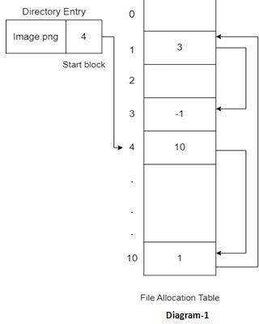

In short, it is an index table of the files kept on the device or in the system is created by the FAT system. There is a record in the index table for every data cluster (data storage area). The next cluster number, an EOF (end of file) marker, any unused disk space, and other specifically designated drive regions are all contained in the entries.

LINUX
  - LINUX stands for Lovable Intellect Not Using XP.
  - Linux is a free and open-source family of operating systems that is resilient and flexible.
  - In 1991, an individual by the name as Linus Torvalds constructed it. The system’s source code is accessible to everyone for anyone to look at and change, making it cool that anyone can see how the system works.
Around 600 + Linux Distributions are available and some of the popular Linux distributions are:
  - MX Linux

  - Manjaro

  - Linux Mint

  - elementary

  - Ubuntu

  - Debian

  - Solus

  - Fedora

  - openSUSE

  - Deepin

Architecture of Linux

Linux architecture has the following components:
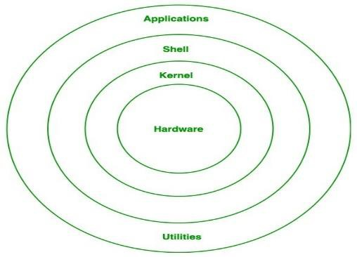
- Kernel: Kernel is the core of the Linux based operating system. It virtualizes the common hardware resources of the computer to provide each process with its virtual

resources. This makes the process seem as if it is the sole process running on the machine. The kernel is also responsible for preventing and mitigating conflicts between different processes. Different types of the kernel are:
  - Monolithic Kernel

  - Hybrid kernels

  - Exo kernels

  - Micro kernels

- System Library: Linux uses system libraries, also known as shared libraries, to implement various functionalities of the operating system. These libraries contain pre- written code that applications can use to perform specific tasks. By using these libraries, developers can save time and effort, as they don’t need to write the same code repeatedly. System libraries act as an interface between applications and the kernel, providing a standardized and efficient way for applications to interact with the underlying system.
- Shell: The shell is the user interface of the Linux Operating System. It allows users to interact with the system by entering commands, which the shell interprets and executes. The shell serves as a bridge between the user and the kernel, forwarding the user’s requests to the kernel for processing. It provides a convenient way for users to perform various tasks, such as running programs, managing files, and configuring the system.
- Hardware Layer: The hardware layer encompasses all the physical components of the computer, such as RAM (Random Access Memory), HDD (Hard Disk Drive), CPU (Central Processing Unit), and input/output devices. This layer is responsible for interacting with the Linux Operating System and providing the necessary resources for the system and applications to function properly. The Linux kernel and system libraries enable communication and control over these hardware components, ensuring that they work harmoniously together.
- System Utility: System utilities are essential tools and programs provided by the Linux Operating System to manage and configure various aspects of the system. These utilities perform tasks such as installing software, configuring network settings, monitoring system performance, managing users and permissions, and much more. System utilities simplify system administration tasks, making it easier for users to maintain their Linux systems efficiently.

Features of Linux

Linux is a versatile and powerful operating system known for its stability, security, and flexibility. Here are some key features:

- Open Source: Linux is free to use, modify, and distribute, which promotes collaboration and innovation.
- Multiuser Capability: Multiple users can access the system simultaneously without interfering with each other.
- Multitasking: Linux can run multiple processes at the same time, efficiently managing CPU resources.
- Portability: It can run on various hardware platforms, from servers and desktops to embedded systems.
- Security: Built with security in mind, Linux features user permissions, access controls, and regular security updates.
- Stability and Reliability: Linux is known for its uptime and performance, making it a preferred choice for servers.
- Package Management: Tools like APT, YUM, and DNF facilitate easy software installation, upgrades, and management.
- Customizability: Users can customize the system extensively, from the kernel to the user interface.
- Command-Line Interface: A powerful command-line interface (CLI) allows for efficient system control and automation through scripting.
- Networking: Strong networking capabilities make it ideal for server environments, supporting a variety of protocols.
- File System Support: Supports multiple file systems, including ext4, XFS, Btrfs, and more.
- Community Support: A large, active community provides extensive documentation, forums, and user support.
- Virtualization: Support for virtualization technologies like KVM, Xen, and containers (e.g., Docker) enhances resource utilization.
- Development Tools: Comes with a wealth of development tools and libraries, making it popular among developers.

These features contribute to Linux's widespread use in servers, desktops, and various other environments.

Linux Directory structure
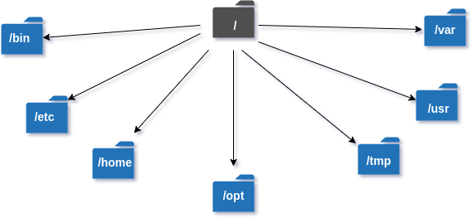

The Linux/Unix file system hierarchy base begins at the root and everything starts with the root directory.
These are the common top-level directories associated with the root directory:

Directories | Description
/bin | binary or executable programs.
/etc | system configuration files.
/home | home directory. It is the default current directory.
/opt | optional or third-party software.
/tmp | temporary space, typically cleared on reboot.
/usr | User related programs.
/var | log files.

- LINUX Commands

Basic Linux Terminal Commands
Linux Commands | Functions
1. Is | Displays information about files in the current directory.

Basic Linux Terminal Commands
2. pwd | Displays the current working directory.
3. mkdir | Creates a directory.
4. cd | To navigate between different folders.
5. rmdir | Removes empty directories from the directory lists.
6. cp | Copy files from one directory to another.
7. mv | Rename and Replace the files
8. rm | Delete files
9. uname | Command to get basic information about the OS
10. locate | Find a file in the database.
11. touch | Create empty files
12. ln | Create shortcuts to other files
13. cat | Display file contents on terminal
14. clear | Clear terminal

Basic Linux Terminal Commands
15. ps | Display the processes in terminal
16. man | Access manual for all Linux commands
17. grep | Search for a specific string in an output
18. echo | Print string or text to the terminal
19. wget | download files from the internet.
20. whoami | Displays the current users name
21. sort | sort the file content
22. cal | View Calendar in terminal
23. whereis | View the exact location of any command typed after this command
24. df | Check the details of the file system
25. wc | Check the lines, word count, and characters in a file using different options

Microsoft Windows Operating System
Microsoft Windows is a group of several proprietary graphical operating system families, all of which are developed and marketed by Microsoft. Each family caters to a certain sector of the computing industry.

History and Development of Windows
It was 1983 when work on “Interface Manager” was started by Microsoft but it was in November 1995, when the first Windows 1.0 was introduced. Later on, with developments in technology, the requirement of the people and increased demand for Graphical User Interface, Microsoft kept releasing revised versions of Operating Systems.

Versions of Windows Operating System
Let us understand the different versions of Windows Operating System along with the features of each of them individually.

Windows 1.0

  - It was released on November 20, 1985
  - Pure Operating Environment
  - Used Graphical User Interface
  - Simple Graphics
  - Offered limited multi-tasking was expected to have a better future potential

Windows 2.0

  - It was released on December 9, 1987
  - 16-bit Graphic User Interface (GUI) based operating environment
  - Introduced Control Panel, and the first version of MS Word and Excel
  - Unlike Windows 1.0, it had the capacity to allow applications to overlap each other
  - It was also the last Windows OS which did not require a hard disk
  - Hardware played an important role

Windows 3.0

  - It was released in 1990
  - It was better at multitasking
  - Used 8086 microprocessors
  - It has both, conventional and extendable memory
  - First version of Windows to gather critical appreciation
  - Better memory/ storage
Note* – None of the above mentioned Windows was Operating Systems. They all came under the category of Windows, working based on a graphical operating environment. It was Windows 95, which was the first Operating System released by Microsoft.

Window 95

  - It was the first complete Operating System
  - It was released on August 15, 1995
  - It merged MS-DOS and Windows products
  - It simplified plug and play features
  - Taskbar and Start menu was introduced with this Windows OS
  - Advanced from 16 bit GUI to 32 bit GUI
  - Long file names could be saved
  - Initially, computers with Windows 95 did not have Internet Explorer installed but by the release date of Windows 95, the first version of Internet Explorer was installed in the software
  - On December 31, 2001, Windows declared this version of OS outdated and ended its support for the same

Windows 98

  - It was released to manufacturing on May 15, 1998
  - It was a 16 bit and 32 bit product based on MS DOS
  - It was not an entirely new version but just a tuned-up version to Windows 95
  - Internet Explorer 4.01 was released along with this Windows version
  - It did not support USB printers or mass storage devices
  - An update to this version “Windows SE” was released in 1999

Windows 2000

  - It was officially released on February 17, 2000. However, its manufacturing had begun in late 1999
  - A core set of features was followed for manufacturing Windows 2000 but 4 different editions, targeting different sectors of the market were released. These included: Server, Professional, Advanced Server and Datacenter Server
  - It was considered as one of the most secure OS ever
  - A local disk manager was introduced with these Windows
  - Multilingual User Interface – it supported many different languages

Windows XP

  - While the manufacturing started on August 24, 2001, the official product was released on October 25, 2001
  - Advanced portable PC support
  - Automatic wireless connection support
  - Fast start-up
  - Better Graphical User Interface (GUI)
  - Help and support centre

Windows Vista

  - It was released on January 30, 2007
  - It had an upgraded version of Graphical User Interface
  - It was the first operating system to use DVD-ROM for installation

Windows 7

  - It was released on October 22, 2009
  - A large number of new features were introduced
  - Redesigned Windows shell with an updated taskbar
  - Incremental upgrade to the Windows line
  - Libraries were added in the file management system
  - A few features from the past Windows were removed
  - Extended hardware support

Windows 8

  - It was released for retail on October 26, 2012
  - Optimisations for touch-based
  - Installed in new devices like Laptops, Mobile phones, tablets, etc.
  - Increased integration with cloud services
  - Windows Store service for software distribution
  - Task manager had been redesigned
  - New security features were introduced
  - Online Applications could be directly downloaded

Windows 10

  - It was released on July 29, 2015
  - Addresses shortcomings in the user interface first introduced with Windows 8
  - A virtual desktop system
  - It had the ability to run windows store apps within windows on the desktop rather than in the full-screen mode
  - Included new icons
  - To reduce storage shortcomings, Windows 10 automatically compresses the file size

Difference between Linux and Windows

S.NO | Linux | Windows
1. | Linux is an open source operating system. | While windows are the not the open source operating system.
2. | Linux is free of cost. | While it is costly.
3. | It’s file name case-sensitive. | While it’s file name is case- insensitive.
4. | In linux, monolithic kernel is used. | While in this, hybrid kernel is used.
5. | Linux is more efficient in comparison of windows. | While windows are less efficient.
6. | There is forward slash is used for Separating the directories. | While there is back slash is used for Separating the directories.
7. | Linux provides more security than windows. | While it provides less security than linux.
8. | Linux is widely used in hacking purpose based systems. | While windows does not provide much efficiency in hacking.
9. | There are 3 types of user account –  (1) Regular , (2) Root , (3) Service account | There are 4 types of user account –  (1) Administrator , (2) Standard , (3) Child , (4) Guest

S.NO | Linux | Windows
10. | Root user is the super user and has all administrative privileges. | Administrator user has all administrative privileges of computers.
11. | Linux file naming convention in case sensitive. Thus, sample and SAMPLE are 2 different files in Linux/Unix | In Windows, you cannot have 2 files with the same name in the same folder.

